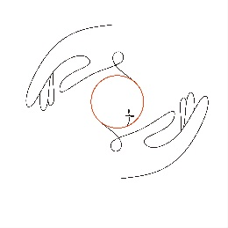

Greetings from Japan. In my calendar, I have written a reminder to myself to write a newsletter at the beginning of every month. Even though we are already a week into August, I feel good about getting this one done. There was a gap of several months between my last two notes. It is hard to believe that we’ve been here over 2 ½ months already. I’m currently looking out at cloud-lined hillsides opposite the Rose Town Tea Garden, and it makes me think how very blessed I am to be here and serving as we do.

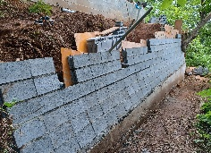Cathy and I, while we do not have nine-to-five jobs or structured ministry positions, find ourselves busy in service each and every day. This is not necessarily a healthy thing, for we do all need our Sabbath times. However, we find our service so rewarding, and the opportunities to support others locally through prayer and helping hands keeps us feeling fulfilled. We are currently filling in for the owners of the Rose Town Tea Garden while they are in North America visiting family. Prior to their departure, we helped them construct a retaining wall at their cabin. Cathy has been an emotional and spiritual support to a lady from one of the churches we attend here. We both were instrumental in recently hosting a Scottish feast for some friends of Edie Town. I’ve come alongside the pastor of the other church, praying with him once a week. We have made ourselves available as hands and feet (and voices) to churches and missionaries locally in whatever they need, which has been a consistent part of our daily ministry.

We took a day off a few weeks back and had a lovely day touring the Showa Kinen Koen (Showa Park), in Tachikawa, Tokyo. One of the highlights was their bonsai exhibit. The park contains the National Museum of Bonsai. I was amazed at how old some of the trees were, one was over 400 years old. Japan is a country where you can get completely away from the city while never leaving the city. It is an amazing country that way.

Just a week and a half from now, Cathy and I will be returning to the US. Our hope, in a nutshell, is to leave Japan with a Certificate of Eligibility in hand which is required to get a working visa here. There is good hope on this end. In January when we applied for the second time, we were told that each request goes through a series of eight approvals, i.e., it is approved by committee. However, in true Japanese fashion, the first to receive the request generally sets the tone for the whole group. We have now received at least six of the eight approvals. Yes, it took six months to get six approvals, each person providing their hanko (name stamp) to the request. At that rate, it may not be in hand before we leave. God doesn’t work on what is convenient to us, we know that, yet it sure would be much easier if we had it before departure. Once in the US, we will apply for the visa, and from what we’ve previously heard, it could take only a week. The timing of getting the visa will determine the date of our return to Japan.

We have a calendar that is already pretty full for the next two months, though. There are a number of regular medical check-ups to be done, vehicle registration update, and the hope of some income through gardening and what have you. In October, we will participate with our church family in two separate gatherings. The first is with a lovely group that shares an intense, prayerful, fellowship with us. After that, we will join in our church’s convocation. Both gatherings are very international, people from the UK, Africa, India, Europe, and Asia (ourselves). There is to be at least one ordination during the convocation, and for Cathy and I, opportunities to serve the leadership of our church through our own giftings.

Praises:

* 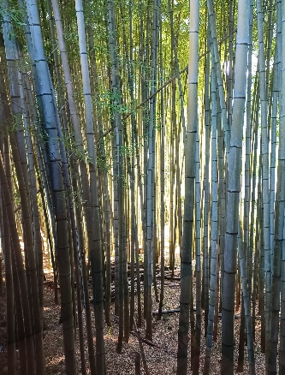The good report on our visa process
* Rose Town Tea Garden staff (representing eight different countries)
* Steve and Edie Town, taking some needed time away with family
* Anticipation of the upcoming home church visit
* God’s abundant provision materially and in opportunities

Prayer Concerns:

* Kurt’s back and arm
* Cathy’s hand
* Provision of a vehicle while in Kansas
* That our service would honor the Lord

**We can be reached at:**

Phone (in US) and Text (anywhere): (805)205-0251  
 Email: [purucker51@gmail.com](mailto:purucker51@gmail.com)  
           [helpsjapan@gmail.com](mailto:helpsjapan@gmail.com)   
 Web:   [helpsjapan.com](http://helpsjapan.com/)  
  
 US mailing address:  
 c/o Shary & Gary Carr  
 2560 Peninsula Rd.  
 Oxnard, CA 93035  
  
 Japan mailing address:  
 1-3-1 Futamatao  
 Ome-Shi, Tokyo 198-0171 Japan